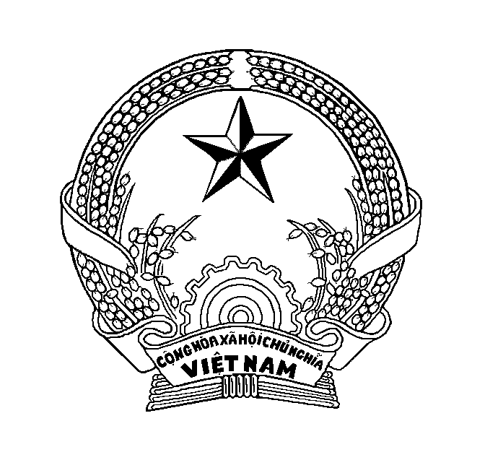

MINISTRY OF AGRICULTURE AND RURAL DEVELOPMENT - SOCIALIST REPUBLIC OF VIET NAM
NATIONAL AGRO-FORESTRY-FISHERIES QUALITY ASSURANCE DEPARTMENT
BRANCH [[TTV]]
Add: [[ADD]]
Tel: [[tel]]; Fax: [[fax]]; E-mail: [[email]]

QUARANTINE/HEALTH CERTIFICATE
For fishery products originated from the Socialist Republic of VietNam
and intended for export to Republic of Korea

Reference No: [[NO]]

I. Consignment information:
Name of Consignor : [[name1]]  Address : [[add1]]  Tel. : [[tel1]] |  |  |  | Name of Consignee: [[name2]]  Address: [[add2]]  Tel.: [[tel2]]
Notify Party : [[party]]
Address : [[add3]]
Tel. : [[tel3]]
Description of Goods : [[goods]]  “Ready-to-eat products” / “Cook-before-use products”  Weight Declared (kg) : [[weight]] |  |  |  | Temperature of product:  Ambient [[ck.01]] Chilled [[ck.02]] Frozen [[ck.03]]
Commodities certified for:
Transplantation [[ck.04]] Ornamental Aquatic animal [[ck.05]] Research & Investigation [[ck.06]] Human consumption [[ck.07]]
No | Species (Scientiﬁc name) |  | Type of packages |  |  | Number of packages | Net weight (kg) |  | Date (period) of Production
Name of the Establishment : [[name4]]
Address : [[addl4]]
Approval Number : [[approval4]]
Container No : [[container]] |  | Bill of Lading No: [[bill]] |  |  | Seal No : [[seal]] |  |  | Mean of Conveyance : [[means]]
Place of Dispatch (port) : [[port1]] |  |  |  |  | Place of Destination (port) : [[port2]]
Date of Dispatch : [[datedispatch]] |  |  |  |  | Source: Wild [[ck.08]] Farmed [[ck.09]]
II. Quarantine /Health Attestation :
This is to certify that :
1. The above fishery products were come from the establishment approved by National Agro-Forestry-Fisheries Quality Assurance Department (NAFIQAD).
2. The products were produced, packed, stored and transported under sanitary condition, which were under the supervision and inspection of NAFIQAD.
3. The products were inspected and not found any disease regulated by the Aquatic Animal Life Control Act of the Republic of Korea based on the Manual of Diagnostic Tests for Aquatic Animals of OIE or the diagnostic methods approved by the Republic of Korea.
4. The products were inspected by NAFIQAD and not found any pathogenic bacteria and harmful substances regulated in the Republic of Korea.
5. The products were verified that not processed by contaminated raw materials affected by contamination happened in April 2016 in coastal areas of 04 central provinces of Vietnam namely Ha Tinh, Quang Binh, Quang Tri, Thua Thien Hue.

Stamp | Date of issue : [[dateissue]]

